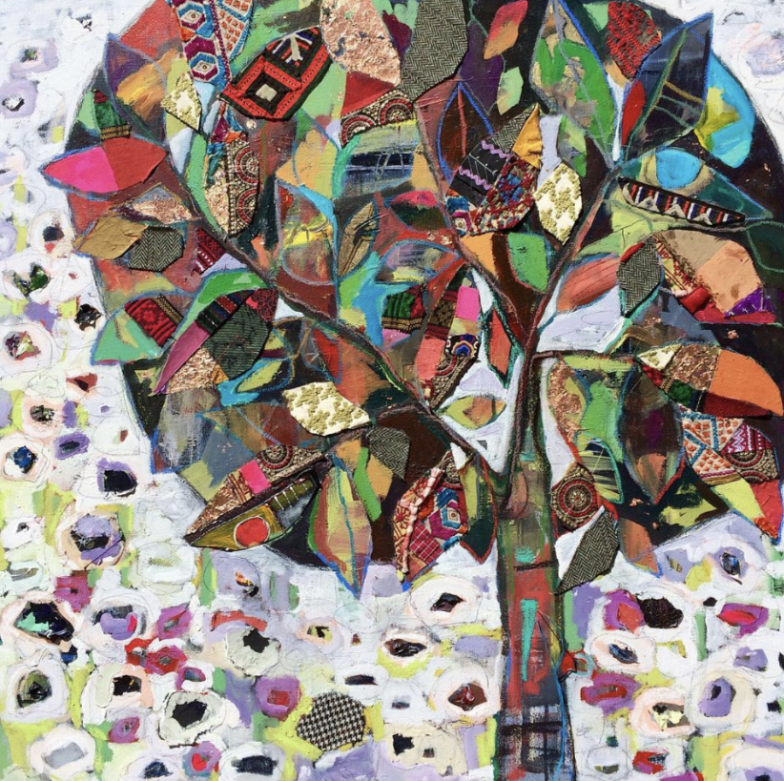
October 9, 2021
Mixed Media Family Tree
Supplies:
- Stretched canvas or panel. Minimum 16x20 up to 30x30
- Anything you wish to glue down to create color and pattern on your tree. (Copies of) letters, cards, photos. Fabric scraps. Wallpaper scraps.
- Water container
- Mixing palette
- GOLDEN Extra Heavy Gel Medium (adhesive)
- Brushes
- Rag for your hands
- An old brush for gel paste (chip brushes from Lowe’s or Home Depot are perfect for this)
- Drop cloth such as old sheet or towels
Suggested GOLDEN paint colors:
- Quinacridone Magenta
- Benzimidazolone Yellow Medium
- Benzimidazolone Yellow light
- Titanium White (bring more than you think you’ll need)
- Naphthol Red LIght
- Phthalo Blue (green shade)
- Phthalo Green (blue shade)
- Indigo (Anthraquinone blue)
- Burnt Umber
Can’t wait to see you in September! Let’s get those brushes MOVING!! Email me if you have any questions staci@staciswider.com. Sign up for my newsletter to stay in the loop. Staciswider.com
~Staci xoxo

